**Q3(A)**

(1) Explain Polymorphism in VB.net with example.

Ans :Polymorphism means "The ability to take on different form“.It is also called as Overloading and Overriding with interface which means the use of the same thing for different purposes.Using Polymorphism we can create as many functions we want with one function name but with different argument list.The function performs different operations based on the argument list in the function call.The exact function to be invoked will be determined by checking the type and number of arguments in the function. **Interface** is an example of polymorphism.

**Interface**

Interfaces in VB.net are used to define the class members using a keyword Interface, without actually specifying how it should be implemented in a Class. Interfaces are examples for multiple Inheritance. Interfaces are implemented in the classes using the keyword ‘**Implements**’ that is used before any Dim statement in a class.

**Example of polymorphism through Interface**

|  |
| --- |
| Public Interface IAmusementParkRide  Sub Ride() End Interface Public Class RollerCoaster  Implements IAmusementParkRide  Public Sub IAmusementParkRide_Ride()  Console.WriteLine("Here we go")  Console.WriteLine("Click, Click ,Click")  End Sub End Class Public Class MerryGoRound  Implements IAmusementParkRide  Public Sub IAmusementParkRide_Ride()  Console.WriteLine("OK will go on it")  Console.Writeline("Nap Time")  Console.WriteLine("Yea its over")  End Sub End Class |

(2) Define & Differentiate: SDI & MDI.

Ans : **SDI**

SDI stands for Single Document Interface. It is an interface design for handling documents within a single application. SDI exists independently from others and thus is a stand-alone window. SDI supports one interface means you can handle only one application at a time.

**MDI**

MDI stands for Multiple Document Interface. It is an interface design for handling documents within a single application. When application consists of an MDI parent form containing all other window consisted of the app, then MDI interface can be used. Switch focus to a specific document can be easily handled in MDI.

**Difference between SDI & MDI**

|  |  |  |
| --- | --- | --- |
|  | **MDI** | **SDI** |
| **Full Name** | Multiple Document Interface | Single Document Interface |
| **Type** | It is the type of Graphic User Interface which is able to show more than a single document at a time on the screen. | It is a Graphic User Interface which is able to show one document at a time on the screen. |
| **Maximization** | All the documents can be maximized in the MDI. | There needs to be a special command in order to maximize the documents. |
| **Switch between documents** | Using special interface inside parent window | Through task /window manager |
| **Grouping** | Naturally implemented | Possible only through special window managers |
| **Example** | Latest web browsers. | Windows Notepad. |

(3) Explain any 3 Common Dialog Controls.

Ans :The Common Dialog Control provides a standard interface for operations such as opening, saving, and printing files or selecting colours and fonts.The common dialog controls are invisible at runtime, and they’re not placed on your forms, because they’re implemented as modal dialog boxes and they’re displayed as needed. You simply add them to the project by double-clicking their icons in the Toolbox; a new icon appears in the components tray of the form, just below the Form Designer. All of these dialog box control classes inherit from the CommonDialog class.The ShowDialog method is used to display all the dialog

box controls at run time.

**OpenFileDialog**

The OpenFileDialog control prompts the user to open a file and allows the user to select a file to open. The user can check if the file exists and then open it. The OpenFileDialog control class inherits from the abstract class FileDialog.Following is the Open File dialog box.

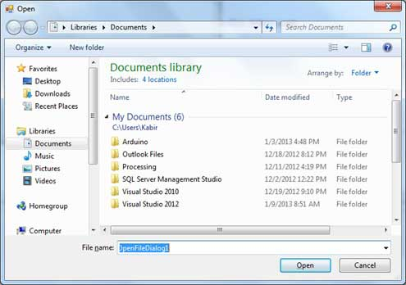

**Example of OpenFileDialog**

|  |
| --- |
| Private Sub Button1_Click(sender As Object, e As EventArgs) Handles Button1.Click  If OpenFileDialog1.ShowDialog <> Windows.Forms.DialogResult.Cancel Then  PictureBox1.Image = Image.FromFile(OpenFileDialog1.FileName)  End If End Sub |

**SaveFileDialog**

The SaveFileDialog control prompts the user to select a location for saving a file and allows the user to specify the name of the file to save data. The SaveFileDialog control class inherits from the abstract class FileDialog. Following is the Save File dialog box.

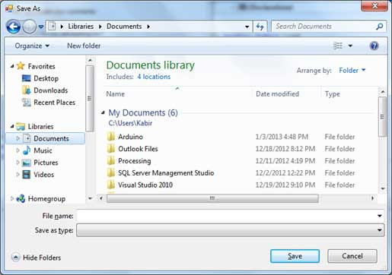

The SaveFileDialog object has properties for setting the initial appearance and functionality of the dialog box, a property for returning the filename selected by the user, as well as a method for showing the dialog box. The object does not itself save the file, but instead provides the information that allows your code to do this programmatically**.**

**Example of SaveFileDialog**

|  |
| --- |
| Private Sub Button1_Click(sender As Object, e As EventArgs) Handles Button1.Click  SaveFileDialog1.Filter = "TXT Files (*.txt*)|*.txt"  If SaveFileDialog1.ShowDialog = Windows.Forms.DialogResult.OK _  Then  My.Computer.FileSystem.WriteAllText _  (SaveFileDialog1.FileName, RichTextBox1.Text, True)  End If End Sub |

**FontDialogBox**

It prompts the user to choose a font from among those installed on the local computer and lets the user select the font, font size, and color. It returns the Font and Color objects. Following is the Font dialog box.

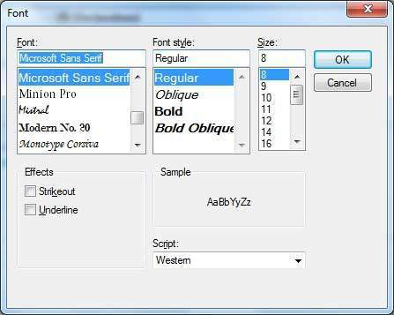

By default, the Color ComboBox is not shown on the Font dialog box. You should set the ShowColor property of the FontDialog control to be True.

**Example of FontDialogBox**

|  |
| --- |
| Private Sub Button1_Click(sender As Object, e As EventArgs) Handles Button1.Click  If FontDialog1.ShowDialog <> Windows.Forms.DialogResult.Cancel Then  RichTextBox1.ForeColor = FontDialog1.Color  RichTextBox1.Font = FontDialog1.Font  End If End Sub |

**Q3 (B)**

(1) Explain any 2 Loop structures in VB.Net with example.

Ans : (1) **Do Loop**

The Do Loop repeats the group of statements while or until the given boolean condition is true. The Do Loop statements are terminated by the Exit Do statement.

There are two methods of Do Loop. The first method is entry loop and the second method is exit do loop. In entry do loop the boolean condition is checks first, and the exit Do-loop checks the boolean condition after the execution of loop statements. The syntax of Do Loop is given below.

|  |  |
| --- | --- |
| **Method 1** | **Method 2** |
| Do { While | Until } condition  [ statements ]  [ Continue Do ]  [ statements ]  [ Exit Do ]  [ statements ] Loop | Do  [ statements ]  [ Continue Do ]  [ statements ]  [ Exit Do ]  [ statements ] Loop { While | Until } condition |

**Example of Do Loop**

|  |
| --- |
| Live Demo Module loops  Sub Main()  Dim a As Integer = 10  Do  Console.WriteLine("value of a: {0}", a)  a = a + 1  Loop While (a < 20)  Console.ReadLine()  End Sub End Module |

**(2) For Next Loop**

The For Next loop repeats a group of statements a specified number of times and a loop index counts the number of loop iterations as the loop executes.The syntax for this loop is :

|  |
| --- |
| For counter [ As datatype ] = start To end [ Step step ]  [ statements ]  [ Continue For ]  [ statements ]  [ Exit For ]  [ statements ] Next [ counter ] |

**Example of For Next Loop**

|  |
| --- |
| Module loops  Sub Main()  Dim a As Byte  For a = 10 To 20  Console.WriteLine("value of a: {0}", a)  Next  Console.ReadLine()  End Sub End Module |

(2) Describe the basic properties or Windows Forms in VB.Net.

Ans : Following table lists down the important properties of a form in VB.Net.

|  |  |
| --- | --- |
| **Property** | **Uses** |
| BackColor | Sets the background color for the form |
| BackgroundImage | Sets the background image for the form |
| Font | Get or sets the font used in the form |
| FormBorderStyle | Get or set border style of a form |
| Text | Provide the title for a Form Window |
| Name | This is the actual name of the form |
| AcceptButton | Get or sets the form button if the enter key is pressed. |
| CancelButton | The button that's automatically activated when you hit the Esc key. |
| AllowDrop | Specifies whether to accept the data dragged and dropped onto the form. |
| Control Box | Determines whether the ControlBox is available by clicking the icon in the upper left corner of the window |
| Autoscroll | Specifies whether to enable auto scrolling. |
| HelpButton | Determines whether a Help button should be displayed in the caption box of the form. |
| MinimumSize | Specifies the minimum height and width of the window you can minimize. |
| MaximumSize | Specifies the maximum height and width of the window you maximize. |

(3) Define & differentiate: Text box & Rich Text Box. Also list down any 3 properties of

Text Box.

Ans :**Text Box :**

A TextBox control is used to display, or accept as input, a single line of text during runtime.The default setting is that it will accept only one line of text, but you can modify it to accept multiple lines.

**Rich Text Box :**

A RichTextBox control is used for displaying, entering, and manipulating text with formatting. The RichTextBox control does everything the TextBox control does, but it can also display fonts, colors, and links; load text and embedded images from a file; undo and redo editing operations; and find specified characters.

**Difference between TextBox and RichTextBox**

A RichTextBox is a better choice when it is necessary for the user to edit formatted text, images, tables, or other rich content. For example, editing a document, article, or blog that requires formatting, images, etc is best accomplished using a RichTextBox.

A TextBox requires less system resources then a RichTextBox and it is ideal when only plain text needs to be edited (i.e. usage in forms).

A RichTextBox mainly used if you want more control over styling the text color, type, font, alignment etc. So anything you can do in Microsoft Word, you can do with a RichTextBox. It can be used to save or display ‘.rtf’ files with ease.

A Textbox is basically used to display or get one line input. You can have a multi-line TextBox which is used mainly to display or get more than one one-liner and keeps you from having to manage multiple TextBox's. Also keeps your UI a little more tidy.